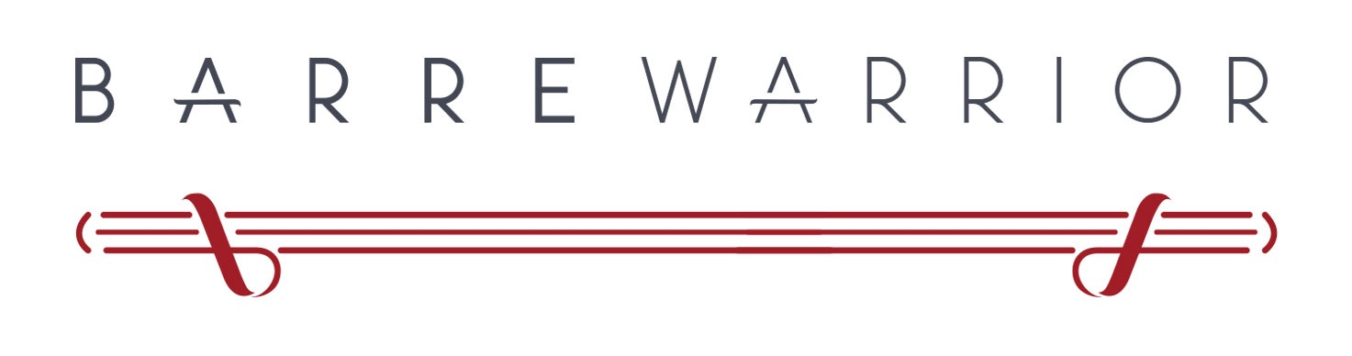
BARRE WARRIOR TEACHER TRAINING REGISTRATION FORM
This form will not impair or enhance your ability to apply. This is simply to better understand your background, influences, reasons and to register.
Name
Date Of Birth
Address
Email
Phone
Occupation
List of Fitness Certifications
(write none or N/A if only applying for personal fitness development)
Physical History:
Other Sport, Yoga, Pilates or Dance background, non-professional or certified
Injuries
Do you have any current or past injuries or health issues that may affect your ability to train?
Reason for Application

Barre Experience
Have you practiced Barre and where and for how long?
Barre and You
What do you love most about Barre/ Barre Warrior?
Availability
Are you available for the following all of the times during the course?

LOCATION & DATES
Dates
Friday 22nd January 1-6pm, Saturday 23rd 12:30-6:30pm, Sunday 24th 12:30-6:30pm
Location
Balance Pilates Cashmere, 131 Hackthorne Road, Cashmere Christchurch

WHAT TO BRING
- Water
- Workout gear and something warm e.g tracksuit/sweater
- Socks or grippy socks if possible
- Snacks (although some light refreshments will be provided)
- A journal/ notebook, pen and highlighter
- A positive attitude of learning growth and enjoyment!

PAYMENT DETAILS

The full Teacher Training payment of $799.00 is due by the 1st day of the course
Or $699 Early bird if paid by January 1st
With Gratitude:

Barre Warrior Limited
ASB
12-3405-0094213-00
CO. GST #118-842-871

